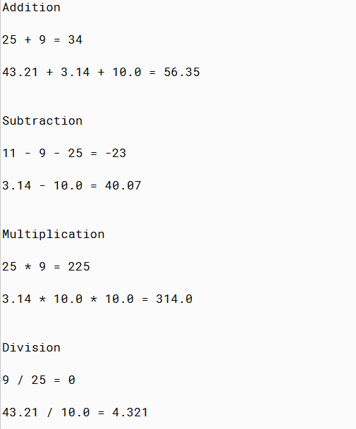

PMR: In my opinion this project was kind of tedious, if you skipped one step it could mess up the project. I am very happy with this result; it took me around two hours to complete. I look forward to what coding has to offer!

/\*\*

\* The Calculations class performs addition, subtraction,

\* multiplication, division, and modulus operations on integers and

\* decimals.

\*

\* @author Anika Jallipalli (replace with your name)

\* @version 09/11/19 (replace with today's date)

\*/

public class CalculationsV6

{

public static void main(String[ ] args)

{

// Declare integer variables

int iNum1 = 25;

int iNum2 = 9;

// Declare double variables

double dNum1 = 43.21;

double dNum2 = 3.14;

double dNum3 = 10.0;

// Addition

System.out.println("");

System.out.println("Addition");

System.out.println("");

System.out.print(iNum1 + " + " + iNum2 + " = ");

System.out.println(iNum1 + iNum2);

System.out.println("");

System.out.print(dNum1 + " + " + dNum2 + " + " + dNum3+ " = ");

System.out.println(dNum1 + dNum2 +dNum3);

//System.out.println();

// Declare integer variables

int iNum4 = 11;

int iNum5 = 9;

int iNum6 = 25;

double dNum4 = 3.14;

double dNum5 = 10.0;

// Subtraction

System.out.println("");

System.out.println("");

System.out.println("Subtraction");

System.out.println("");

System.out.print(iNum4 + " - " + iNum5 + " - " + iNum6 + " = ");

System.out.println(iNum4 - iNum5 - iNum6);

System.out.println("");

System.out.print(dNum4 + " - " + dNum5 + " = ");

System.out.println(dNum1 - dNum2);

//System.out.println();

// Declare integer variables

int iNum8 = 25;

int iNum9 = 9;

double dNum6 = 3.14;

double dNum7 = 10.0;

// Multiplication

System.out.println("");

System.out.println("");

System.out.println("Multiplication");

System.out.println("");

System.out.print(iNum8 + " \* " + iNum9 + " = ");

System.out.println(iNum8 \* iNum9);

System.out.println("");

System.out.print(dNum6 + " \* " + dNum7 + " \* " + dNum7 + " = ");

System.out.println(dNum6 \* dNum7 \* dNum7);

//System.out.println();

// Declare integer variables

int iNum11 = 25;

int iNum12 = 9;

double dNum8 = 43.21;

double dNum9 = 10.0;

// Division

System.out.println("");

System.out.println("");

System.out.println("Division");

System.out.println("");

System.out.print( iNum12 + " / " + iNum11 + " = " );

System.out.println(iNum12 / iNum11);

System.out.println("");

System.out.print(dNum8 + " / " + dNum9 + " = ");

System.out.println(dNum8 / dNum9);

//System.out.println();

// Declare integer variables

int iNum14 = 11;

int iNum15 = 9;

double dNum10 = 10.0;

double dNum11 = 3.14;

// Modulus operator

System.out.println("");

System.out.println("");

System.out.println("Modulus");

System.out.println("");

System.out.print( iNum14 + " % " + iNum15 + " = " );

System.out.println(iNum14 % iNum15);

System.out.println("");

System.out.print(dNum10 + " % " + dNum11 + " = ");

System.out.println(dNum10 \* dNum11);

//System.out.println();

// 2.03 Additional int Equations

System.out.println("");

System.out.println("");

int iNuma=77;

int iNum102=84;

int iNumf=99;

int iNum104=34;

int iNumh=10;

System.out.println("2.03 Additional int Equations");

System.out.println("");

System.out.print(iNuma + " / " + iNumf + " \* " + iNum102 + " - " + iNum104 + " = ");

System.out.println(iNuma / iNumf \* iNum102 - iNum104);

System.out.println("");

System.out.print(iNumh + " \* " + iNum102 + " / " + iNumf + " % " + iNumh + " = ");

System.out.println(iNumh \* iNum102 / iNumf % iNumh);

System.out.println("");

System.out.print(iNumh + " + " + iNumf + " - " + iNuma + " % " + iNumh + " = ");

System.out.println(iNumh + iNumf - iNuma % iNumh);

//2.04 Additional double Equations

System.out.println("");

System.out.println("");

double dNumd=3.7;

double dNumg=10.11;

double dNumj=21.21;

double dNume=113.77;

double dNumm=101.00007;

System.out.println("");

System.out.println("");

System.out.println("2.04 Additional double Equations");

System.out.println("");

System.out.print(dNumd + " + " + dNume + " \* " + dNumm + " - " + dNumj + " = ");

System.out.println(dNumd / dNume \* dNumm - dNumj);

System.out.println("");

System.out.print(dNume + " / " + dNume + " / " + dNumg + " - " + dNumj + " = ");

System.out.println(dNume \* dNume / dNumg % dNumj);

System.out.println("");

System.out.print(dNumm + " \* " + dNumd + " - " + dNume + " % " + dNumg + " = ");

System.out.println(dNumm + dNumd - dNume % dNumg);

} // end of main method

} // end of class